**Bugs of Website**

1. **It should come as Anodiam in chrome tab heading**
2. **Home Page**
3. The logo should be changed.





The new logo will be –

**N.B. – Logo Image is mailed**

1. The color of the marked menu bar should be transparent, not black.





On the home page, the **anodiam** should be removed.We will give you a new background image.

**N.B. – The replacement image will be mailed**

1. Provide a login button on the header which should lead to the following url:

<https://www.anodiam.com/login>



Delete the above section as it is not required.

1. Remove the above logo which is marked inside red square
2. **USE THIS SAME FONT STYLE (Font should be Oxygen) FOR WRITING ALL PAGE HEADERS, NO UNDERLINES.**



1. The button width is too long.

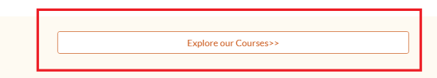

1. The tooltip text is moving up and down while scrolling for all buttons.

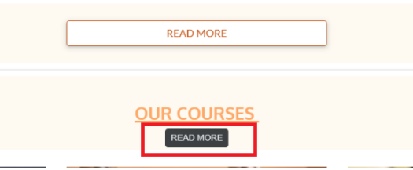

1. **About Us**
2. The image will be mailed for About section.



1. It should be “About Us” with capital U. Make it bold: **About Us**
2. The page looks too plain and unprofessional. Choose a suitable theme so that the contents stand out more.



1. **Courses**
2. New background image and other images are mailed.



1. Remove the underline from **Courses**
2. Make the para spacing uniform (Write the course name heading like : “**AI & Data Science**

**For Professionals**”

If necessary**)**



1. All course images are to be changed.
2. Delete numberings 1,2,3…

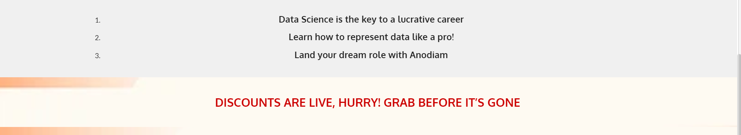

1. Delete the part (“Discounts are live….”) marked in red rectangle.
2. **Gallery**
3. Background image will be different and new images are attached.

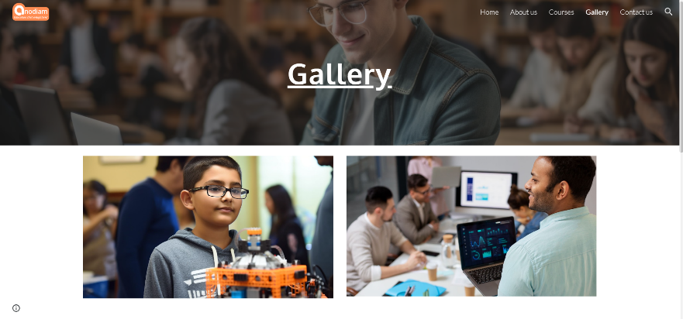

1. Remove the underline from **Gallery.**
2. **Contact Us**
3. Keep everything uniform and lined up. Move the **“Reach Us at”** part up.

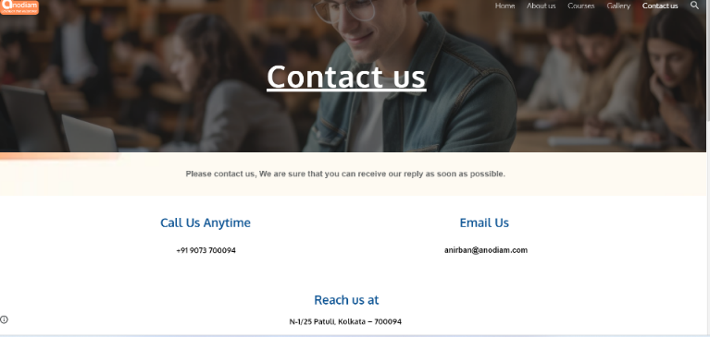

1. It should be Us with U capital in Reach Us at.
2. **Footer**

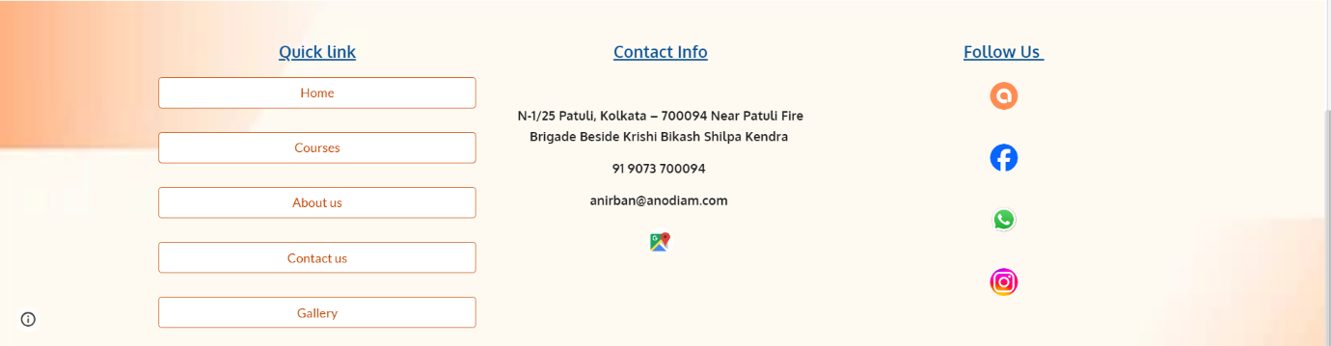

1. Delete the quick link part which is marked in red square as it is not required.
2. Give icons for address, mobile no. and email ID. Also turn them into hyperlinks so that clicking on them leads to the respective stuff.
3. Replace our app icon with playstore’s icon.
4. Find a better theme color and design for the footer.
5. **Web tab**

Replace the logo with the one from the mail.

